The Foundation Stage – Overview & Policy

The Three Prime Areas
Characteristics of Effective Learning
We prioritise these three Prime areas for all our pupils. We believe by supporting our pupils to be successful in these areas and with regard to their individual barriers to learning they will move on to be well rounded, successful, independent learners. At Hebden Green we believe that the Characteristics of Effective Learning provides us with a platform on which to analyse our pupils specialist needs and ensure we allow them to fully access all of their learning.

For all pupils, these areas of learning are used as vehicles to drive their learning in the Prime areas. Some of our pupils are able to learn discreet skills within these areas linked to their developmental stage. Some approaches we use within the foundation stage consistently link with whole school schemes to ensure our pupils are able to consistently develop key skills throughout their school life at Hebden.

The Four Specific Areas

Expressive Arts and design
Understanding the World
Maths
Literacy

Overview

This policy reflects the school values and philosophy in relation to the teaching and learning of our youngest pupils. It also reflects current legislation as outlined in the Statutory Framework for the Early Years Foundation Stage 2023 (Department of Education) and recommendations from Development Matters in the Early Years Foundation Stage (EYFS) (non-statutory guidance), Birth to 5 matters (Non-statutory - Early Years Coalition partners and Cosy Fund), Early Years Autism standards (Autism Education Trust) and PMLD core and essential service standards (2017)

“Our goal is for our very special learners and young people with SEN to have the best opportunities and support so that as far as possible they can succeed in education and their careers, live as independently and healthily as they are able to and be active members of their communities. For a small number of young people, independent living may not be possible. It is for these young people that we want to ensure the best quality of life with support for them and to fulfil their potential and support their parents and carers” (Green paper 2011)

Introduction

At Hebden Green School we have extended the Early Years Foundation Stage until the end of Key Stage 1 and we call it ‘The Foundation Stage’. The Foundation Stage at Hebden Green School is based on the aims and principles of the Early Years Foundation Stage Framework. This document is designed to support children’s learning, development and care from 2 to 7 years. We use this framework as a basis on which to integrate our specialist provision. The aim of this provision is to support our special learners within their very early and crucial years of learning. This early learning creates the foundations on which all future learning can be based and, we believe, determines how successful our pupils will be in their future learning pathways and throughout their lives. We see parental engagement as an integral part of our Foundation Stage offer to ensure that our pupils will flourish through discrete skills-based learning, play and many opportunities to engage in real life learning both at home and in school.

Our Foundation Stage pathway offers an outstanding provision which has been created to meet the needs of children with multiple barriers to learning, including complex medical and physical needs, autism, severe learning difficulties (SLD), multi-sensory impairments (MSI) sensory processing difficulties (SPD) and moderate learning difficulties (MLD). Children who attend Hebden Green have an EHCP which outlines their individual barriers to learning and our aspirations for their future. From the age of 2 our pupils begin their journey to reach their lifelong potential in relation to their future employment, good health, participation in the community and independence. Our ambitious, challenging and stimulating curriculum enables children to holistically embed these skills alongside their educational programmes. Learning for young children is a rewarding and enjoyable experience in which they explore, investigate, discover, create, practice, rehearse, repeat, revise and consolidate their developing knowledge, skills, understanding and attitudes. Our highly skilled staff at Hebden Green allow our pupils to access early childhood experiences whilst continuing to support their individual learning needs.

Aim: We aim to offer the best for every child through ensuring we offer

We ensure we do this by:

- Recognising that all children are unique.
- Providing our children with a key worker with whom they build their biggest bonds.
- Offer a fully integrated and cohesive transdisciplinary approach to learning.
- Understanding and breaking down individual pupils 'barriers to learning' to allow them to thrive.
- Understanding that children develop in individual ways at varying rates- physically, cognitively, linguistically, socially and emotionally.
- Providing a safe, secure and caring environment where children feel happy and know that they are valued.
- Fostering and nurturing children’s self-confidence and self-esteem through their developing awareness of their own identity.
- Teaching them to express and communicate their needs and feelings in appropriate ways using augmentative and alternative communication where needed (including assistive technology).
- Encouraging children’s independence and decision making, supporting them to learn through their mistakes and building their resilience.
- Developing children’s understanding of social skills and the values and codes of behaviour required for people to work together harmoniously.
- Supporting children to develop care, respect and appreciation for others, including those with beliefs, cultures and opinions differing to their own.
- Understanding the importance of play in children’s learning and development - that of 'learning to play' and 'learning through play'.
- Providing learning experiences in play which reflects personal interest and areas of curiosity in order to encourage and develop their natural desire, interest, excitement and motivation to learn.
- Providing experiences which build on children’s existing knowledge and understanding in order to challenge, stimulate and extend their learning and development.
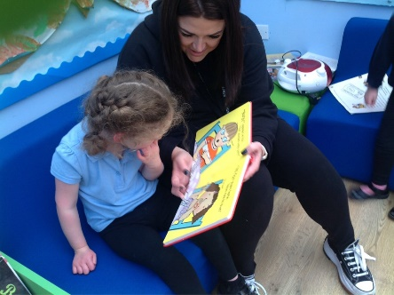
- Providing effective learning opportunities in a range of environments, inside and outside.
- Additional support is sort for children to ensure they reach their true potential.
- Working in strong partnerships with our pupils’ families.

Environment - The best for every child

Great care and thought is given to ensure that the Foundation Stage's environment is inclusive and enables learners to flourish at Hebden Green. Our environments remain adaptive, and our team continuously evaluate the needs of the children and change the environment accordingly. All of the Foundation Stage classes have access to the outdoor areas which is appropriate for our ever-growing cohort of pupils and their needs, a dedicated space for mealtimes, a fully adapted bathroom area, low stimulus 'work time' areas and more stimulating play-based provision spaces which provide opportunities for our pupils to extend and apply their learning.

The autism environment within the Foundation Stage is noticeably different as the environment is low stimulus at all times. The environment has areas for co-regulation and self-regulation to support each child to regulate their emotions throughout their day. Children with autism can find it difficult to engage in adult led learning activities. Practitioners working with these children are highly trained to use a variety of approaches, techniques and strategies to encourage each individual child to engage in purposeful learning activities and play in order for them to reach their full potential.

Safety Health and Welfare - High quality care

We deeply value the children’s safety, and we aim to provide a safe and secure environment at all times. We also aim to educate children about risks as well as the need for boundaries and rules. We talk to children about any risks connected to the activities they are doing at an appropriate level linked to their learning abilities. Risk assessments are in place across the provision; these include the classrooms, outdoor learning areas and individual pupils. These are shared with staff and parents and are updated where needed. These balance the need for safety with the need to provide some challenges. We believe in educating children about the need for themselves to evaluate the risk involved in what they are doing, as this a skill for life. We also support our teaching team to scaffold risk taking and allow our children to try new activities ensuring all risks have been reduced where possible. Developing and building our pupils self-esteem, confidence and resilience remains a high priority in our Foundation Stage pathway and is therefore implemented within our pupils learning opportunities and curriculum.

Personal Care Plans are used across the foundation stage to ensure that every moment is a valuable experience for our pupils. We prioritise the early skills associated with personal safety. Our pupils are taught about keeping themselves safe through our PSED curriculum which encompasses their bodily awareness and understanding of acceptable behaviour. We recognise that a large percentage of our pupils need assistance with everyday routines and feel it is vital that they are able to anticipate a routine and have a clear understanding of this. Our routines are followed throughout the school and as the pupils develop communication skills, they are able to develop their control of these situations, again developing a life skill.

Early Years Pupils Premium

Children attending specialist settings are not eligible for Early Years Pupil Premium. Early year’s pupil premium is vital to enable us to further enhance our provision for our most vulnerable pupils. The Early Years Pupil Premium is extra funding paid to early years providers to improve outcomes for eligible children. We ensure families whose child would be in receipt of EYSSP receive the same provision as those in mainstream. We work closely with families to identify eligible pupils and share where the funding is spent and the outcomes we hope to achieve. As a school we believe the funding is best spent across four areas: training, specialist equipment, developing the home learning environment and widening life experiences.
Safeguarding and PREVENT - High Quality Care

Safeguarding our pupils is always our priority. The Foundation Stage is encompassed under whole school Safeguarding procedures and approaches. All staff are trained in Safeguarding level one and PREVENT and these are updated annually. All staff at Hebden Green take part in regular safeguarding updates and training to ensure our understanding is current and remains at the forefront of everything we do. We work closely with families and outside agencies to ensure our pupils receive exceptional levels of care and that information is shared between.

Pupils are taught how to safeguard themselves through our independence curriculum. We believe that by teaching our pupils about control we equip them with lifelong skills to ensure their own safety.

Key Person - High Quality Care, The best for every child

We use a key person approach within the pathway to ensure our children and families build solid and functional relationships with a key member of the staff team within the class they are in. This could be either the class teacher or a teaching assistant they are familiar with.

The Key Person is responsible for:

- Supporting a small number of pupils across their learning and daily routine.
- Facilitating learning and activities as directed by the class teacher while using own initiative to scaffold activities towards pupils’ individual targets and needs.
- Knowing key pupil’s IEP targets and drive learning towards them at all times.
- Recording learning and progress across the daily routine via our tapestry observation platform which can be shared with families.
- Ensuring observations and assessments are meaningful and impact on the pupils happiness and wellbeing via ‘pupil profiles’ and shared with parents and other multi professionals including the GA and MDA team.
- Communicating with parents, along with the class teacher, via home school diaries.
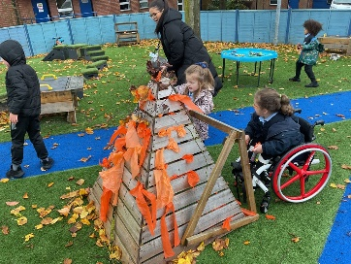
- Being an advocate for the pupils they work with – they are their voice to ensure others understand them and that they have the highest level of provision at all times across the day.
Pedagogy

Teaching in the Foundation Stage is delivered in accordance with the governments Statutory Framework for the Early Years Foundation Stage (2023). Within this framework providers in early years education must bring together children’s welfare and learning and development requirements through four themes: ‘A Unique Child’, ‘Positive Relationships’, ‘Enabling Environments’ and ‘Learning and Development’.

At Hebden Green School we provide our pupils with this framework by providing routine, structure and carefully planned, targeted adult led, adult directed, and child-initiated activities all based around play and the pupils’ individual motivators. Individual Education Plan (IEP) targets are set for each pupil with the purpose of enhancing opportunities for learning and personal development across every part of their day. This planned curriculum is then enhanced by a variety of enrichment opportunities to allow pupils to extend and enhance their learning in differing contexts and with a variety of adults.

There are seven areas of learning in the EYFS framework: Literacy, Mathematics, Understanding the World, Expressive Arts and Design plus three 'Prime' areas of learning– Communication and Language, Personal Social and Emotional Development, and Physical Development. Our curriculum allocates the majority of the children's learning time to these 3 'Prime areas'. All the learning that goes on in the Foundation Stage is designed to promote these core skills and to provide opportunities for children to generalise them, with the specific areas as our vehicles and our prime areas which drive these activities and experiences. Each class timetables vary depending on the pupil’s level of need and focus barriers to learning.

Learners follow the Foundation Stage curriculum throughout the Early Years, Years 1 & 2. This extension to the EYFS has enabled the teaching team to allow our youngest pupils to progress through a developmental curriculum and ensures that every pupil is able to access their next stage at Hebden Green with the essentials to their journey. Throughout the Foundation Stage, alongside our multi-disciplinary team, our staff will ensure that every pupil has an identified communication system and any identified equipment. This developmental curriculum plays a diagnostic role in establishing which of the Pathways the child will begin in Year 3, e.g., Pathway 1, 2 or 3.

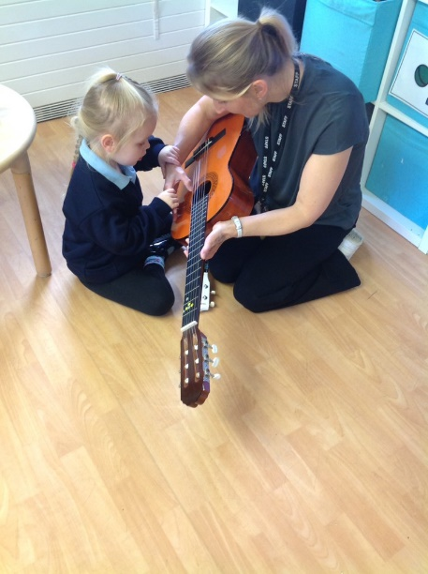
Class timetables are constructed around the principle that every moment of the school day is a learning opportunity. Each aspect of school life is a planned learning experience and linked to personalised curriculum targets and Individual Education Plans.

In the early years we organise the day to provide an appropriate balance between the following:

- Child Initiated Activities - children make choices from within the learning environment to
meet his/her outcome for learning.
- Adult Initiated Activities- practitioners provide the resources to stimulate and consolidate learning.
- Adult Directed Activities – Children engage in planned activities to meet their own
Individual Education Plan targets and curriculum next steps.
- Indoor, outdoor, enhanced and continuous provision learning.

Continuous and enhanced provision

At Hebden Green School we believe many of our children need active learning through hands on, play based activities. Our continuous provision provides our children access across the day with practical activities and resources to support them with their learning at their own appropriate level.

The Continuous provision can enable all children to explore recently learnt skills, practice new and previously learnt skills, and follow their own interests. Practitioners are able to ‘enhance’ the continuous provision offered to the children through adding additional resources and making more explicit links to practitioner’s adult led sessions. This combination of continuous and enhanced provision gives practitioners a framework within which they can set their adult-led activities, being sure that children have plenty of opportunities to practice and improve their skills, knowledge and confidence in independent or supported learning.

Observing children within the areas of the continuous provision is a crucial part of the practitioner’s role and the findings from these observations have an impact on what is planned for the children’s next steps. Through observations, practitioners are able to identify the strengths and needs of children, their behaviour, interests and patterns of learning and development. We believe at Hebden Green that skills and knowledge demonstrated within the continuous and enhanced provision shows true learning.

For those children within the Foundation Stage who have significant barriers to their learning such as physical, sensory or behavioural then the adult directed activities may be increased or decreased accordingly. Each child is unique and each child’s learning will be tailored to ensure that they are happy, safe and motivated to learn and succeed at Hebden Green School

At Hebden Green we understand that children with autism do not relate to others or learning in typical ways. Continuous provision is available to each child in the autism environment however the resources are limited as we are aware that our children with autism can become overwhelmed with lots of choice and busy environments. Continuous provision is carefully planned to make sure all areas of learning and development are accessible throughout the week.

The Development of Play

"Learning to play to achieve learning through play"

In the Foundation Stage we recognise the vital importance of children’s play. It is an essential and rich part of our children's learning process, supporting them in all areas of their development. Play is a powerful motivator encouraging children to be creative, to develop their own ideas, enhance their understanding and support their language use. Play is also flexible and able to suit the preferred learning style of the child. It can provide multiple ways for children to learn a variety of different skills and concepts.

Many of our pupils in the Foundation Stage are not able to play; they have not yet achieved the required skills sets within the various 'Levels of play' to enable them to access a provision which requires them to 'Learn through play'. Through our unique curriculum we support these pupils to build their play skills through discreet 'learning to play' sessions. These skills are then supported throughout the provision and whenever a child accesses the continuous provision activities.

A Multi-Disciplinary Approach

An essential part of the Foundation Stage's success is our work with our Multi Professional teams; Physiotherapy, Speech and Language therapy, Nursing, and the Visual and Hearing impairment teams (including MSI). Therapies form an essential part of our pupil’s entitlement and are seen as an integrated part of our curriculum.

Our therapy teams work closely with us to ensure input is integrated into their daily routine, provided within the familiar classroom environment, and is facilitated by the pupils’ key workers. Our therapy teams also provide support with individual target setting and individual program development. Multi professional targets are integrated into pupils IEPS to ensure this is always a priority within their learning.

Curriculum

Prime Areas

We prioritise these three Prime areas for all our pupils and believe by supporting our pupils to be successful in these areas and with regard to their individual barriers to learning they will move on to be well rounded, successful, independent learners in an appropriate Pathway.

Prime Area: Personal Social and Emotional Development

Our provision: Personal Social and Emotional Development (PSED) underpins and is integrated into our daily routines and learning. PSED helps our children to develop a positive sense of themselves and others. We aim to support our children to be confident learners by supporting them to develop their social skills, play skills, a respect for others and the curiosity to want to explore and learn. Our children are encouraged to be as independent as possible in relation to their personal care skills but also through their ability to transition between activities and follow the routine of the school day through a variety of sensory and symbolic cues. Play skills are taught discretely and are linked to the ‘levels of play’ based on Parten’s theories. Independence is promoted across the whole school day and all activities are seen as vital learning opportunities. PSED also allows our pupils in the Foundation Stage to develop the core skills in order to wait, persist and direct attention as needed. We believe it is of upmost importance to support our pupils to learn how to manage their own emotions in order to become a positive member in society. For our pupils we believe this area is integrated within the Characteristics of Effective Learning via the Pupil Profile.

Our aim: For all pupils to leave the Foundation Stage being independent, engaged, and motivated learners, who are able to learn as part of a group, follow the daily routine and interact appropriately with others.

Targets: All children have an Individual Education Plan target linked to PSED derived from the appropriate long-term objective on their EHCP.
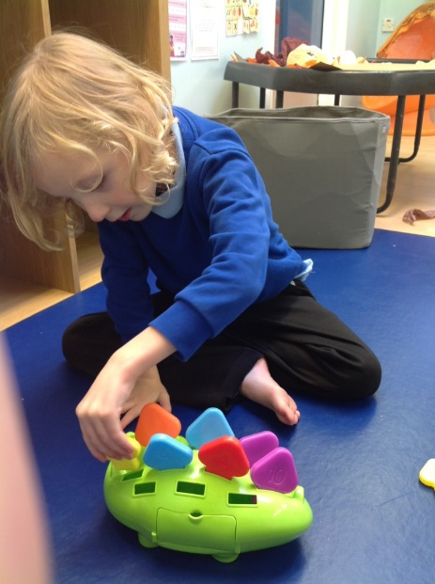
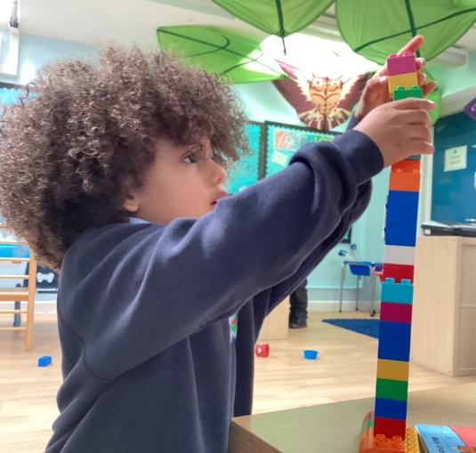

Prime Area: Communication and Language

Our Provision: Communication and Language supports our children to develop their understanding and expression of language, including listening skills. A language rich environment is provided through a total communication approach and differentiated to meet each child’s needs. Developing communication skills linked to speaking and listening is a priority area of the curriculum for our pupils. The pathway works very closely with the Speech and Language Therapy team to ensure each pupil has an individual and functional communication system which they can use to access all activities, routines and learning opportunities. Communication is at the forefront of all learning activities that are planned for our pupils at Hebden Green, allowing them to fully participate and for learning to remain purposeful. We find that providing stimulating opportunities that include stories, rhymes, poems, and non-fiction texts at an appropriate level, allows our pupils to engage with a breadth of experiences which models and encourages them to continue to develop their own communication. Please refer to the Hebden Green’s Reading Spectrum which links very closely with our Communication and Language curriculum.

Our aim: For all pupils to leave the Foundation Stage with a ‘voice’ and a communication system which supports them to demonstrate their true cognitive ability, wants, wishes, and needs within the Pathway that they move in to.

Target: All children have an Individual Education Plan target linked to Communication and Language derived from the appropriate long-term objective on their EHCP.

Prime Area: Physical Development

Our provision: Physical Development helps children to learn by being active. This helps our children to gain confidence, develop their coordination and movement, positional awareness, core strength and stability, which in turn allows them access to their curriculum. For those children who have a physical barrier to learning, we provide in conjunction with our Conductive and Physiotherapy team, with an individual physical development program to which they follow each day. Physical development is an integral part of our curriculum and we support our pupils to develop their individual skills in this area across all activities and routines. Our children also access a PE session once a week to enhance gross and fine motor skills through exciting and fun activities.

Our aim: For all pupils to leave the Foundation Stage with the equipment, skills and physical plan to allow them to be ready for the Pathway they access.

Target: All children have an Individual Education Plan target linked to PD derived from the appropriate long-term objective on their EHCP.

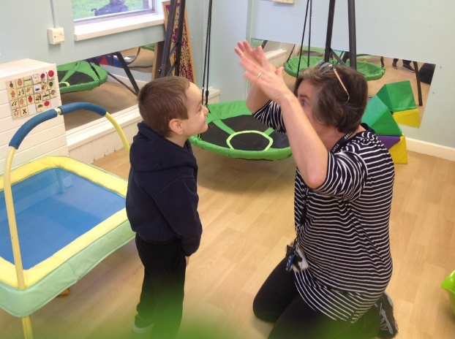
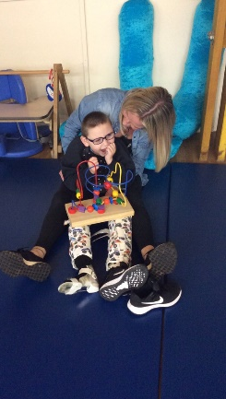

Specific Areas

These areas of learning are used, for the majority of our pupils, as vehicles to drive their learning in the Prime areas. Some of our pupils are able to learn discreet skills within these areas.

Specific area: Literacy (See Hebden Green’s reading spectrum)

Our provision: Literacy based activities are used as vehicles to drive our priority Prime areas for the majority of our pupils. We provide many activities to support the development of reading and writing skills appropriate to each child individually. We have a wide range of books and other shared reading materials within the pathway which children can access independently and with others within their continuous play provision and learning environments. Each term, learning is linked to a theme and a focus text; pupils use this text to drive many of their communication and literacy skills. At Hebden Green, we believe all children are readers and we have developed a whole school ‘Reading Spectrum’ which our Foundation Stage pupils follow, to ensure they continue to develop their own individual reading pathway as they move through school. As we know, children learn to read in different ways and at different rates. Our pupils in the Foundation Stage follow a reading approach which is appropriate and functional for the individual child. These include approaches such as our ‘Song of sounds’ phonics approach, See and Learn language and reading approach and intensive interaction. The development of writing is supported not only via traditional writing activities but creatively through, for example the use of computers, iPad, sensory play and fine motor skills. We provide our children with a variety of adult led, adult initiated and also child-initiated experiences in order for them to learn, apply and contextualise their Literacy skills.

Our aim: For all pupils to leave the Foundation Stage following an appropriate and progressive reading approach tailored to meet their own individual communication and learning needs.

Target: All children have a reading and writing curriculum next step target appropriate for their individual learning level, which is supported and progressively changed through our observation and assessment process.

Specific area: Mathematics

Our provision: Mathematics based activities are used as vehicles to drive our priority Prime areas for the majority of our pupils. Our children are provided with a wide range of activities to help them to develop an understanding and an experience of number, using number, numerical patterns and shape, space, and measure. We believe Mathematics in the Foundation Stage is at its most purposeful when it is based on real life situations and put into context for our pupils. For example, ‘I have two shoes – 1,2’ ‘How many cups do we need at snack time?’ and developing an understanding of our routines across our day. We follow our whole school maths approaches that are relevant for our individual pupils and classes. These include ‘White Rose maths’, ‘See and Learn maths’ and ‘rhythmical intentions’. This is to ensure we can introduce strategies our pupils will become familiar with as they move through school and ensure maths mastery in all pathways.

Mathematics at its early stages is routines and schedules which are embed across the school day and also through our continuous and enhanced provisions. We see the importance of class teachers and the role of the Key persons to play a vital part in order to develop early mathematical skills through language, modelling, questioning and providing opportunities for mathematical challenge.

Aim: For all pupils to leave the Foundation Stage with a good understanding of mathematical concepts which is in line with their individual developmental stage in preparation for future learning in the appropriate Pathway.

Target: All children to have a maths next step target appropriate for their individual learning level, which is supported and progressively changed through our observation and assessment process.

Specific area: Understanding the world

Our provision: Understanding the World provides children with the opportunity to develop the knowledge, skills and understanding that help them to make sense of the world through their senses. To help children to do this we enable them to use a range of tools and adaptive technology safely. We provide opportunities for them to encounter creatures, people, plants and objects in their natural environments and in real life situations. We see it as a vital learning opportunity to ensure our pupils visit places such as parks and libraries, to ensure they have well-rounded childhood experiences and also continue to develop an understanding of their own community and the ever-changing diverse world we live in. This allows us to continue to support and widen our pupil’s vocabulary.

Aim: For all pupils to leave the Foundation Stage having had a wide range of experiences of technology, the natural world and people who we share our world with.

Target: All children to have a Understanding the World next step target appropriate for their individual learning level, which is supported and progressively changed through our observation and assessment process.

Specific area: Expressive Art and Design

Expressive Art and Design enables our children to explore and play with a wide range of media and materials. Children are also provided with opportunities and support to share their thoughts, ideas and feelings through a variety of activities in art, music, movement, dance, imaginative and role play activities and design and technology. We provide our pupils with a weekly Interactive Music session with our music specialist; this is a wonderful session and really enhances our pupil’s musical abilities and interest.

Aim: For all pupils to leave the Foundation Stage with a range of skills that they can utilise in a way to creatively express themselves.

Target: All children to have a Expressive Arts and Design next step target appropriate for their individual learning level, which is supported and progressively changed through our observation and assessment process.

All seven areas of learning and development address children’s physical, cognitive, linguistic, social and emotional development. No one aspect of development stands in isolation from the others as all areas of learning and development are closely interlinked. This ensures the delivery of a holistic, child-centred curriculum which allows children to make lots of links between what they are learning, creating a solid foundation in which all future learning will build upon. All areas of learning and development are given equal weighting and value, however for our youngest children, the Prime areas of learning are the focus for setting their Individual Education Plans.

Religious Education

Our children’s Religious Education entitlement is in line with the expectations set out in the Cheshire West and Chester SACRE and the EYFS Statutory Guidance educational study of Understanding the World (2023). These state that pupils in the Foundation Stage must receive 5% RE learning across their weekly timetable including a daily act of Collective Worship. The focus for the Foundation Stage is to begin by focusing on our individual pupils world and family beliefs, allowing them to explore their own personal experiences. Christianity is then our focus and taught through 5 areas: Beliefs, Practices, Values, Themes and Concepts. We also value other beliefs and cultures in the Foundation Stage and our pupils are provided with opportunities to learn, understand and celebrate them during our half termly themed days and weekly assemblies. As our Foundation Stage is extended for those pupils in Key Stage one, we also ensure the curriculum coverage of Christianity, Judaism and Islam is also included within our offer. At Hebden Green we believe the teaching of RE to our pupils is closely linked to the concepts behind the British Values initiative. Our pupils are able to join in group activities, learn through song and stories, and experience the values of a religious and British and culture; caring, friendships, respect and environment.

RE is mapped across the Long-Term Planning through discrete sessions and activities and also holistically across other themes and learning.

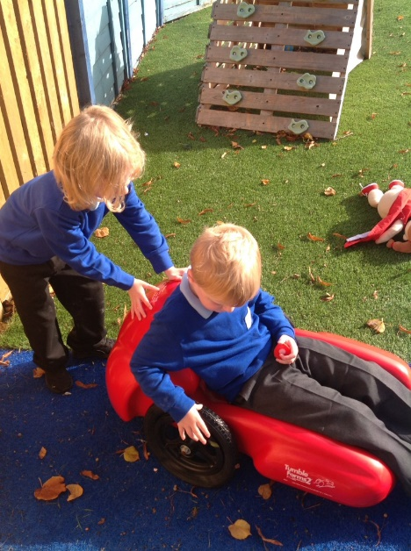

British Values and SMSCD in the Foundation Stage

British Values at Hebden Green is linked directly to the implementation of the Prevent agenda. We see that our moral purpose is to educate our pupils in the core areas of; democracy, rule of law, tolerance of religions, individual liberty and mutual respect and how that is appropriately relayed to our pupils.

The EYFS curriculum in its sheer existence has always promoted these areas and as a school we have looked at these drivers and applied them appropriately to our pupils learning. Throughout the Foundation Stage our classes have the ‘High 5’ concept which links to how we have interpreted the British Values to apply to our pupils. Each class has class values, and this links back to the British Values and how they apply to our pupils and their learning. These are often shared with our pupil’s during class ‘surprise time’ when we reflect on our personal achievements.

Access to Learning

We believe at Hebden Green that the Characteristics of Effective Learning as outlined in the Early Years Framework provides us with a platform on which to analyse our pupils’ specialist needs and ensure we allow them to fully access all of their learning.

There are 3 areas within the characteristics of Effective Learning:

- Playing and exploring: Children investigate and experience things, and ‘have a go’.

- Active Learning: Children concentrate and keep on trying if they encounter difficulties and enjoy achievements.

- Creating and Thinking critically: Children have and develop their own ideas, make links between ideas, and develop strategies for doing things.

To ensure pupils develop these skills we use the initial first six weeks when children join us to carry out extensive observations and assessments to create each child an individual Pupil Profile. This profile links to the above 3 areas and considers the priority needs of our pupils linked also to physical development, cognition, communication and PSED alongside these 3 areas. These profiles are also contributed to by families and our multi professional teams. As the children progress, we track their progress within their Characteristics of Effective Learning through our daily observations and assessments which we share with our parents and families via our online Tapestry learning journey.

Planning

We value the planning process greatly within the Foundation Stage and realise fully that well planned, prepared, and resourced activities greatly enhance our pupils’ ability to learn and progress. We ensure all activities are meaningful, linked directly to pupils individual learning and that all areas of the curriculum and provision aim to scaffold and support learning holistically.

Every part of the day is a learning experience in our strive to make the most of every child's time in school. The team work together to plan which ensures a progression of activities and learning opportunities are provided across the whole of the Foundation Stage years to ensure our children make as much progress as possible and achieve the desired outcomes by the time they move into one of the Pathways as they enter Key Stage 2.

Planning starts and ends with the pupils and their enjoyment of what they are doing stays at the forefront of everything we are trying to achieve. This will ensure that our pupils build a lifelong ‘love for learning’.

Long term planning
The Foundation Stage follows a four-year rolling program which provides themes for each term; many of the learning activities are linked to these themes. Each half term the plan rotates which elements of the Prime areas are to be focused on and which Specific areas are to be used as vehicles to enhance the learning within the prime areas. Although this map provides focus areas to ensure coverage and breadth of experience, our teachers still ensure learning is pitched at where the pupil is at and meets their individual learning needs linked to their IEPS. The long-term planning is adapted each year, taking into account which pupils will be accessing it, their home-life experiences, previous learning experiences and also their individual learning needs.

We also offer a variety of opportunities across the year for our pupils to experience activities linked to different festivals, cultures and celebrations. This is mapped to each term and is delivered in the form of a theme day.

Medium term planning
The Medium-term planning within the Foundation Stage serves as an overview of the activities which will be on offer in any given week and states the learning focus areas for each half term. This is a multipurpose document. Initially it is to provide a document which is simple to follow by all the members of the team and by parents and families. These are sent home half termly to provide parents with an overview of the learning and activities their children will be accessing and how they can support their children’s learning at home. Secondly it acts as either a document on which to outline sessions and activities in more detail or as a signpost to where short-term plans / activity plans or individual programs can be found.

Short term planning
We use a variety of short-term planning across the Foundation Stage, activity plans, short term plans, individual activities, session outlines. All of which serve to act as a guide to leading / facilitating an activity, the elements the children rely on with regards to structures and cues and the resources needed. These plans also provide direction to how the wider staff team can support the learning and scaffold it to the next level. Planning within the FS does not directly include pupils’ targets or outcomes - any of these documents need to be read next to our children's individual target plans.
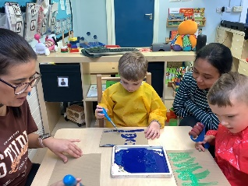
Assessment: Target Setting and Assessment

“Assessment plays an important part in helping parents, carers and practitioners to recognise children’s progress, understand their needs, and to plan activities and support”
(Statutory Framework for the Early Years Foundation Stage 2023)

The main assessment method is through practitioners’ observations of children in different teaching and learning contexts, including adult focused activities, and child-initiated play, within the indoor and outdoor environments. Observations take place on a daily basis (both formally and informally). Practitioners make time to carry out planned observations of individuals and groups of children regularly. They also make spontaneous observations in order to capture significant moments of children’s learning. These are shared on our Tapestry online learning journey; which parents have full access to. All practitioners are involved in observing children and use observations to support their developing knowledge of individual children. It informs them of children’s abilities, needs, interests, play schemas and learning styles. Observations are evaluated, children’s learning priorities are identified, and relevant learning opportunities are planned to support children to make the next steps and progress.

Learning Journeys via our Tapestry online system, record children’s progress over the academic year in all areas of learning and development of the EYFS framework and focuses on their individual ‘wow moments’ and next step targets. Samples of children’s work are gathered, along with photographic evidence and observations. Parental observations are also included and encouraged within this system.

There is continuous monitoring and assessment of each child’s development using ‘Early Years Steps’ through the on-line assessment package, SOLAR. This assessment framework allows us to celebrate our pupils’ small steps of achievements and allows us to support our pupils to make progress which is relevant to their individual and specialised learning. The assessment cycle for The Foundation Stage is in line with the whole school system. Pupils attainment is tracked termly and information from this tracking informs pupils next steps.

Pupils will be baselined within 6 weeks of entry to the school. The pupils EHCP along with therapist reports and parents’ views, will culminate with the baseline assessment to set each child an Individual Education Plan. The next terms planned activities will ensure that every opportunity is given to ensure that the child can reach/exceed their targets.

The Individual Education Plan is sent home and parents will be regularly informed of the progress their child is making towards their personalised targets.

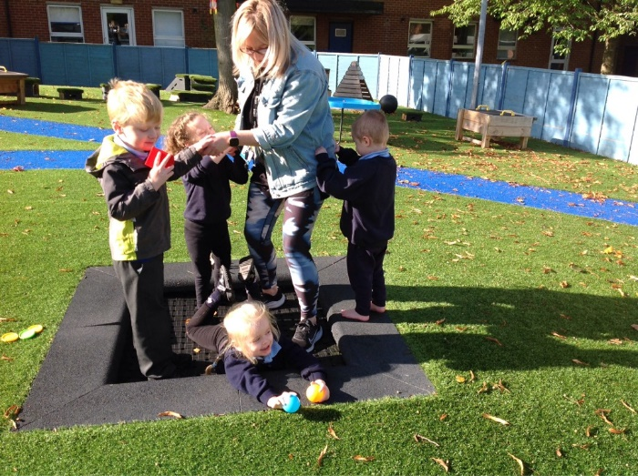

Partnership with Parents and Families

At Hebden Green School we recognise the importance of establishing positive relationships with parents, as highlighted by the EYFS framework. We understand that an effective partnership between school and home will have a positive impact on children’s learning and development. Practitioners endeavour to encourage the regular sharing of information with parents; this is done via a daily home school diary, emails, regular Facebook updates, face to face contact, parent information sessions, our Tapestry online learning journey and regular phone calls alongside our family support worker where needed.

We value the role of parents as children’s primary educators. We encourage parents to share their unique knowledge of their child, providing further insight into the child as an individual (e.g., characteristics, interests, experiences, likes, dislikes). On entry to Hebden Green each family will receive a welcome pack from a Preparation for Learning (PfL) Lead which includes a Pupil Profile and Motivator assessment, these documents are sent home for parents to complete to help us understand their unique child. This supports our team in establishing interesting and stimulating learning experiences, responding to children’s needs and interests.

The school has a friendly, open-doors ethos and practitioners are available to talk to parents at the beginning and end of the day, via home school dairies or telephone or face to face contact. Parents are always welcomed into school and encouraged to discuss any concerns they might have. Each term we offer a formal parent’s session to discuss children's progress and invite parents to offer a target which they would like their children to work on. We also invite parents in to take part in regular 'come and learn' sessions where they have the opportunity to join in with their child's favourite play activity, meet the team and share a supported and fun activity with their child.

The lead of the Foundation Stage, alongside other teaching colleagues, also offer a variety of parent information sessions across the year. These may include but not be exclusive to:

- Our Foundation Stage - Who we are and what we do.
- Communication Strategies - OoR / PECS / Visual boards / Signing / intensive interaction
- Cueing in.
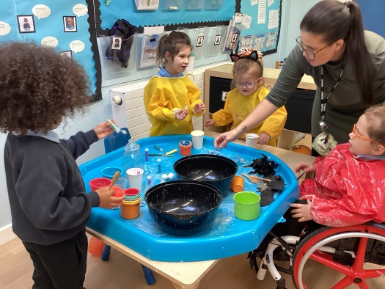
- Behaviour vs Communication
- Play development.
- Physical Development
- Independence skills
- Reading at Hebden Green

Self-Regulation, Executive Functioning

Self-regulation is the ability to control emotional and physical impulses, it helps children guide their thoughts, emotions and behaviours to accomplish a goal. The cognitive aspect of self-regulation is called executive functioning and includes working memory, the ability to control impulses and the ability to think flexibly. At Hebden Green we are aware that these skills can be difficult for our children especially those children who have autism and therefore we spend a lot of time to teaching and encourage these skills to support them to grow into self-regulating adults.

At Hebden Green we encourage self-regulation and executive functioning through:

- Focus thinking time and time to persist with activities.
- Observing the children and enhancing or scaffolding learning
- Time for each child to self-regulation or co-regulation with an adult.
- Teaching children to wait for their “wants” to be met.
- Show how to bounce back when challenges occur.
- For some children a sensory diet is in place to support their ability to regulate.
- Throughout the day we talk to the children about the activities they have participated in and what they are going to do later in the day. This supports their ability to start to plan what they are going to do next. Some of our children also have individual timetables to support their understanding of what is happening next.
- For some children we teach how to take a ‘break’ from an activity when their arousal levels rise to regulate their bodies, thoughts and emotions in order to be able to return and continue an activity.

Professional Development and Appraisals

We offer a comprehensive of planned and on-going professional development for our staff across whole school. This includes regular updates on Safeguarding, PREVENT, behaviour (PBS), health and hygiene and first aid including paediatric as part of discrete CPD or included within planned INSET days and weekly evening training / information sessions. Through the year external CPD is sourced and offered to various staff members across the school in line with pathway or whole school needs and usually linked to the School Development Plan.

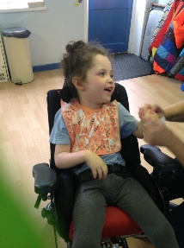
As a member of the Foundation Stage Team, the staff are provided with on-going professional development sessions which are based on self-evaluation of the provision and are provided weekly in half term blocks led by the lead of the Foundation Stage or other teaching colleagues within the pathway in order to share expertise and experience; these sessions alternate between a specialist and EYFS focus as appropriate. Staff are encouraged to drive their own learning and to ensure their knowledge is current and up to date with the ever-changing Early Years sector. Teachers and Teaching Assistants also receive a comprehensive appraisal and supervision process lead by SLT which supports their individual development and on-going CPD needs in line with school vision and individual aspirations.

