Weekly Home Learning Activities EYFS

- Please join us for a daily online circle time lesson. Check in on Microsoft Teams from 9:30 for a 9:45 start. Caroline and I will also be holding daily reading/maths sessions at 11am every day, please see session outlines and resources needed below.

Week Beginning:18th January 2021 | Learning Overview: Our topic this half term is ‘People who help us.’ | Class: Hawks
Key learning Focus and vocabulary for this week: Our focus occupations we are learning about this week are ‘Nurses and Doctors’ and our sign/word of the week is therefore ‘Ill/sick’. Please find image below to help with the Makaton sign. This will also be introduced during our video call circle time sessions. If you can, please write this word for your child and keep referring to it across the week.(It will help them become familiar with the shape and recognition of the word)
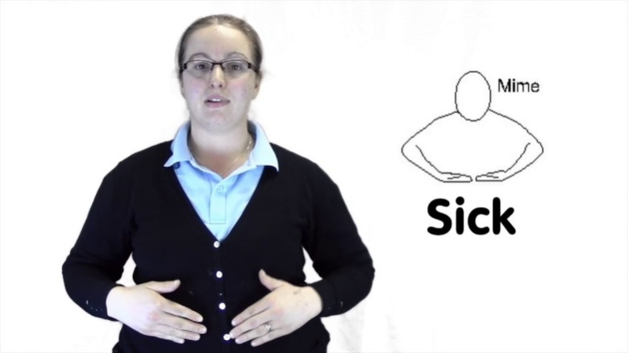

Key Learning Tasks this week– Target: To complete a minimum of one task each day and upload learning to tapestry where you will then receive feedback, support and next steps if required. These tasks will take place during our online video call sessions at 11am each day. Please refer to the correct day for the set task.
Area of learning | Task | Resources
Reading | Task 1: Monday –  See and Learn group – Video call at 11am with Caroline.  Please ensure your child has a copy of the book ‘Who’s eating?’ they looked at last week. We will begin by recapping this book together, looking at specific books skills – front cover, back cover, title and turning pages one at a time.  We will then focus on matching sight words, including the words found in the book ‘Who’s eating?’. Our words will be: doll, bear. Please find these words which have been sent to you via post.  Phonics group –Tricky words! – Video call at 11am with Annabel.  Today the children will be learning the tricky word ‘into’. They will look at how the word has two words within it, learn how to recognise it within sentences (please print the ‘into’ sentence sheet) and learn how to write it. They will finish by playing a game of tricky word bingo!Please have this ready for the session, this will need to be printed or will be sent to you via post. | See and Learn:  .  - See and Learn words: 2x doll, 2x bear.
Phonics:

- Pen/pencil and paper
- Tricky word bingo sheet.
- Into sentence recognition sheet.
 | Task 2: Wednesday  See and learn group – Video call with Caroline at 11am.  Please ensure your child has a copy of the book ‘Who’s eating?’. We will read through this book again together and then recap and match the words we looked at yesterday. These words are: doll, bear. If the children are able to match these independentlytoday, we will then go onto selecting these sight words by pointing to the words when they are called.  Phonics group –Video call with Annabel at 11am.  The children will be continuing to work on their reading and writing skills. We will be looking at rhyming ‘ip’ words today. We will be looking at the rhyming pattern within the words together and have a go at reading the words. We will then be given a ‘ip’ sheet where we need to practise matching the word to the picture and then the other sheet where we need to write the word ourselves next to the picture. | See and Learn:  - See and learn words: 2x doll, 2x bear.
Phonics:

- ‘ip’ matching word to picture sheet.
- ‘ip’ writing words next to picture sheet.
 | Task 3: Friday –Spellings!!  See and Learn group – You will be taking part in an online video call session with Caroline at 11am.  Your child will be introduced their new spelling to learn over the next week and ready for their spelling test next Friday! Please find your letter sheet which has been either emailed or sent to you via post. Your focus letter is:m  Phonics group – You will be taking part in an online video call session with Annabel at 11am.  You will begin by having a test on the words introduced last week. Your child will then be introduced their new spellings to learn over the next week and ready for their spelling test next Friday! Please make sure your child has a pen/pencil and paper ready for this session. Your focus words are: sip, tip, nip | See and Learn:  - A wide tub of rice your child can trace and draw in.  - Pen/pencil and paper.  - Letter formation sheet ‘n’.
Phonics:

- Pen/pencil and paper.
Maths | Task 1: Tuesday –Objectives:  - Beginning to organise and categorise objects.  This week the focus is to sort objects according to their shape. The children will be asked to sort the shapes into groups and name that shape. If you have shapes at home (this could be in the form of a shape sorter or a jigsaw) please use these. If not please find separate shape sheet, where you will need to print and cut out the shapes for your child before the session starts.  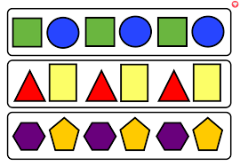  If your child can independently name and sort the shapes into groups, we will then focus on using these shapes to make 2 and 3 repeating patterns. E.g., circle, square, circle, square, etc. OR circle, square, triangle, circle, square triangle etc. | - A device to take pictures and upload learning onto tapestry.  - Shape sorting sheet.  - Paper and pen/pencil.
 | Task 2: Thursday –Objectives:  - Selects a small number of objects from a group when asked, for example, ‘please give me one’, ‘please give me two’.  - Knows that numbers identify how many objects are in a set.  - Finds one more or one less from a group of up to five objects.  - In practical activities and discussion, beginning to use the vocabulary involved in adding and subtracting.  If your child was able to complete all tasks on Tuesday independently, they will now get a number of shapes when asked and then be asked to predict how many they will have if they have one more or one less without using the objects to begin with. (Please use the shapes from yesterday) They can check their answers by using the shapes to count afterwards. They can begin to have ago writing their one more and one less sums on paper/whiteboard. E.g., 4+1=5, 4-1=3 etc.  If your child needed some support completing the activity on Tuesday, we will begin to recap Tuesday’s activity (please have the resources you printed out ready for today’s session again please). We will then ask the children to get us an amount of shapes when asked e.g., get me 1, get me 2, get me 3 etc. | - A device to take pictures and upload learning onto tapestry.  - Shape sorting sheet.  - Paper and pen/pencil.

Useful links, websites and interactive resources
Subject/ Activity | Website and link | What area to focus on
Maths, Phonics, Literacy, Expressive Arts and Design, Understanding of the World | Starfall - http://more.starfall.com/?t=288954945&nrb=1&y=1 | Allow the children to explore and navigate around this website to play on the activities. Make sure you click on ‘Kindergarten’ option.
Phonics | Phonics play - https://www.phonicsplay.co.uk/Phase2Menu.htm | Any reading game is suitable for the children to use, make sure you click on ‘phase 2’.
Maths | Topmarks Maths -https://www.topmarks.co.uk/Search.aspx?Subject=37 | Games that allow children to practice their counting and sorting maths skills. E.g. Teddy numbers.
Communication and Language, Personal Social and Emotional development, Expressive Arts and Design, Understanding the World, Literacy, Maths. | The Oaks National Academy -  https://www.thenational.academy/online-classroom/specialist/#subjects | Hawks class will need to click on the ‘applying learning’ section for each session

Other activities for this week (Wider Curriculum/ IEP linked)
Subject | Task | Resources
Expressive Arts and Design | - If you have a doctors/nurses play kit and dolls at home, allow your child time to play with these toys. Play with your child and take it in turns to be the doctor/nurse and the patient, allowing them to talk about their own experiences and ideas during play.  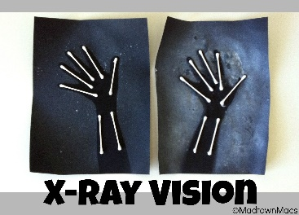  - Or if you have white paint or cotton ear buds at home, you could create an arm x-ray picture! Please see pictures for ideas on how this could look! | - Doctors role play toys.  - Paper, white paint, cotton ear buds, glue.
Understanding the World | Please watch this video to recap the different occupations of people who help us. You can also learn the Makaton signs along the way.  Makaton Topic - PEOPLE WHO HELP US - Singing Hands - YouTube  As our focus for this week is ‘nurses/doctors’ please follow this link to watch a video which explains to the children what nurses/doctors do and the equipment they use.  Doctor Checkup for Kids - Types of Doctors - Social Studies | Kids Academy - YouTube  What Does A Doctor Do? Pre-School Educational Video - YouTube  - Please fine the ‘appointment sheet’ that I have either sent to you via email to print or via post. Can the children practise write their name forming their letters correctly? Can they write their family members name and give them a doctors appointment. | - A device to watch the YouTube videos.  - Appointment sheet.
Weekly Challenge and Extended Learning

- Children to continue to work on their independence skills by helping to make their lunch. This could be making a sandwich, or helping to mix ingredients etc.

*These skills are so important for your child to continue to practise and also link to many of your children’s IEP targets relating to independence*

I would LOVE to see your child’s efforts of practicing these skills on tapestry so please upload where you can!

