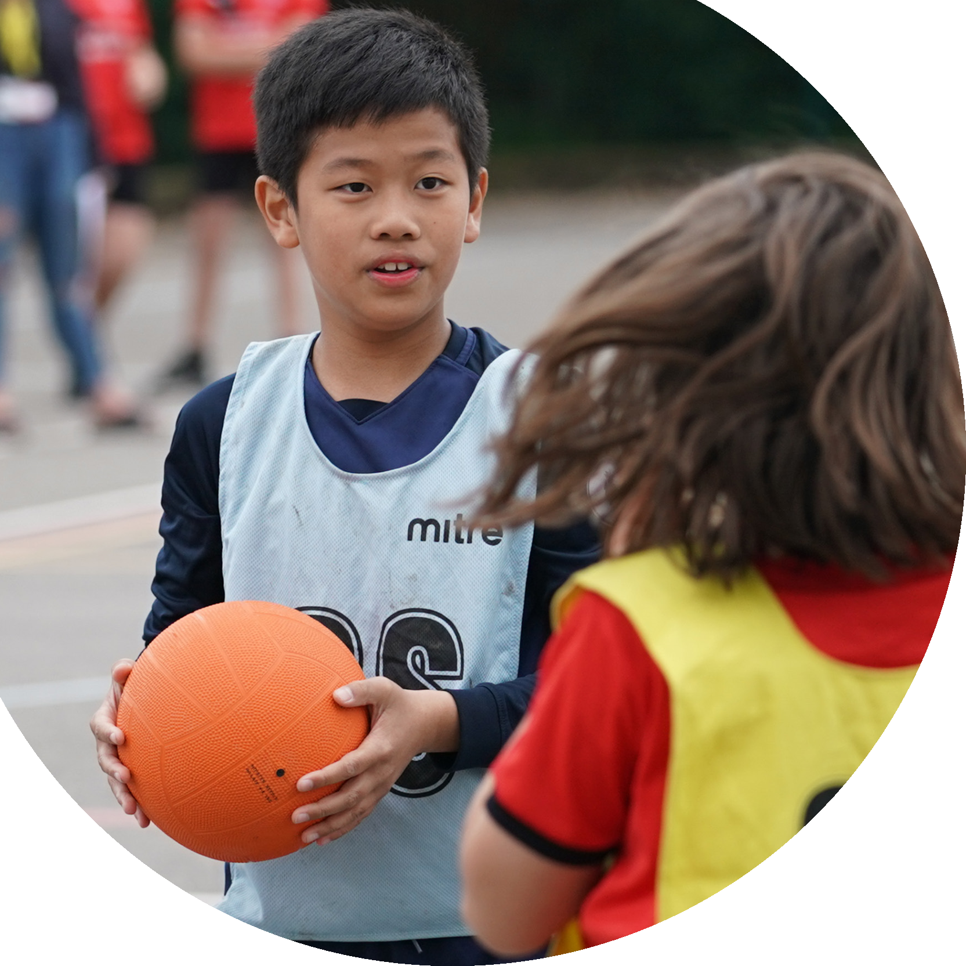

**Evidencing the**

**impact of the**

**Primary PE and**

**sport premium**

Website Reporting Tool

2024/2025

**Created by**

**Commissioned by**



It is important that your grant is used effectively and based on school need. The Education Inspection Framework makes clear there will be a focus on **‘whether leaders and those responsible for governors all understand their respective roles and perform these in a way that enhances the effectiveness of the school’**.

Under the Quality of Education Ofsted inspectors consider:

**Intent** - Curriculum design, coverage and appropriateness

**Implementation** - Curriculum delivery, Teaching (pedagogy) and Assessment

**Impact** - Attainment and progress

To assist schools with common transferable language this template has been developed to utilise the same three headings which should make your plans easily transferable between working documents.

Schools must use the funding to make **additional and** to the quality of Physical Education, School Sport and Physical they offer. This means that you should use the Primary PE and

* Develop or add to the PESSPA activities that your school already offer
* Build capacity and capability within the school to ensure that improvements made now will benefit pupils joining the school in future years
* The Primary PE and sport premium should not be used to fund capital spend projects; the school’s budget should fund these.

Please visit gov.uk for the revised DfE guidance including the 5 key indicators across which schools should demonstrate an improvement. This document will help you to review your provision and to report your spend. DfE encourages schools to use this template as an effective way of meeting the reporting requirements of the Primary PE and sport premium.

We recommend you start by reflecting on the impact of current provision and reviewing the previous spend.

We recommend regularly updating the table and publishing it on your website throughout the year. This evidences your ongoing self-evaluation of how you are using the funding to secure maximum, sustainable impact. Final copy must be posted on your website by the end of the academic year and no later than the 31st July 2021. To see an example of how to complete the table please click HERE.

|  |  |
| --- | --- |
| |  | | --- | | **Swimming Data**  Please report on your Swimming Data below. | |

|  |  |
| --- | --- |
| |  | | --- | | **Details with regard to funding**  Please complete the table below. | |

|  |  |
| --- | --- |
| Meeting national curriculum requirements for swimming and water safety.  N.B. Complete this section to your best ability. For example you might have practised safe self-rescue techniques on dry land which you can then transfer to the pool when school swimming restarts.  **Due to exceptional circumstances priority should be given to ensuring that pupils can perform safe self rescue even if they do not fully meet the first two requirements of the NC programme of study** | 0 |
| What percentage of your current Year 6 cohort swim competently, confidently and proficiently over a distance of at least 25 metres?  **N.B.** Even though your pupils may swim in another year please report on their attainment on leaving primary school at the end of the summer term 2021. Please see note above | 0 |
| What percentage of your current Year 6 cohort use a range of strokes effectively [for example, front crawl, backstroke and breaststroke]? Please see note above | 0 |
| **What percentage of your current Year 6 cohort perform safe self-rescue in different water-based situations?** | 0 |
| Schools can choose to use the Primary PE and sport premium to provide additional provision for swimming but this must be for activity **over and above** the national curriculum requirements. Have you used it in this way? | No – pupils access swimming linked to their SEND and therapy needs |

|  |  |
| --- | --- |
| |  | | --- | | **Action Plan and Budget Tracking**  Capture your intended annual spend against the 5 key indicators. Clarify the success criteria and evidence of impact that you intend to measure to evaluate for pupils today and for the future. | |

|  |  |  |  |  |
| --- | --- | --- | --- | --- |
| **Academic Year:** 2024-2025 | **Total fund allocated:** | **Date Updated: Jan 2025** | |  |
| **Key indicator 1:** The engagement of all pupils in regular physical activity – Chief Medical Officers guidelines recommend that primary school pupils undertake at least 30 minutes of physical activity a day in school | | | | : |
|  |
| **Intent** | **Implementation** | | **Impact** |  |
| Your school focus should be clear what you want the pupils to know and be able to do and about what they need to learn and to consolidate through practice: | Make sure your actions to achieve are linked to your intentions: | | Evidence of impact: what do pupils now know and what can they now do? What has changed?: | Sustainability and suggested next steps: |
| That all pupils have access to a robust curriculum that enables them to maintain and develop their physical skills linked to curriculum expectations and individualised expectations as set out within the Education, Health and Care Plan | All pupils have focused access to:  Timetabled PE (specific to Pathway curriculum)  Sensory Circuits/swim or other sensory based activities (Physical/Sensory, SEMH)  Daily Physical Programmes (as developed with the Physio/OT team)  Sports events and trips (linked to Pathway curriculum)  Visits and trips that focus on physical independence (linked to the Pathway Curriculum)  The further development of accreditation linked to PE – ASDAN Entry level award for PE  Bespoke play areas to meet age, phase and need | |  | Moderation linked to Pathway curriculum offer to ensure consistency of offer.  Termly review of IEP – which is linked to outcomes within EHCP  Year Annual review to explore targets and outcomes within EHCP linked to individual need |
| **Key indicator 2:** The profile of PESSPA being raised across the school as a tool for whole school improvement | | | |  |
|  |
| **Intent** | **Implementation** | | **Impact** |  |
| Your school focus should be clear what you want the pupils to know and be able to do and about what they need to learn and to consolidate through practice: | Make sure your actions to achieve are linked to your intentions: | | Evidence of impact: what do pupils now know and what can they now do? What has changed?: | Sustainability and suggested next steps: |
| PE and sports within the curriculum reviewed linked to further embed best practice  Events, activities, visits and other wider planning highlights and drives the importance of sports across the setting | Inclusion in school improvement planning – Mind – enhanced and embedded Pathway curriculum  Work with governors looking at my body, time allocation, what is included, linking to IEP and EHCP  SDP project exploring Beyond the curriculum to ensure consistency, effectiveness and continuity of all trips and visits including sporting  - | |  | Offer built into the curriculum and reviewed as part of whole school curriculum updates  Beyond the curriculum to be rolling programme and offer built into pathways |

|  |  |  |  |  |
| --- | --- | --- | --- | --- |
| **Key indicator 3:** Increased confidence, knowledge and skills of all staff in teaching PE and sport | | | |  |
|  |
| **Intent** | **Implementation** | | **Impact** |  |
| Your school focus should be clear what you want the pupils to know and be able to do and about what they need to learn and to consolidate through practice: | Make sure your actions to achieve are linked to your intentions: | Funding allocated: | Evidence of impact: what do pupils now know and what can they now do? What has changed?: | Sustainability and suggested next steps: |
| For staff to be empowered to create and deliver programmes linked to PE and sport that meet the individual needs of the pupils as stated within the Education, Health and Care Plan  For staff to deliver a curriculum that meets individual needs but also explores a range of interesting and engaging sports | Curriculum PE is adapted to meet the needs of the children.  Multiagency professional liaison for specific and individualised physical programme e.g. Physiotherapy  Staff develop key skills in physical activity through joint multiagency working and are supported by wider teams to accurately deliver physical programmes  round robin for PE to have the expert teachers teaching PE  Equipment and resources are continually improved to enable staff to prepare and teach specialist sessions linked to need e.g. purchasing of equipment, replacing markings to support active sports e.g. boccia markings | |  | To ensure that staff have specific SEND training linked to the physical, medical and sensory needs as part of the in house CPD offer |
| **Key indicator 4:** Broader experience of a range of sports and activities offered to all pupils | | | |  |
|  |
| **Intent** | **Implementation** | | **Impact** |  |
| Your school focus should be clear what you want the pupils to know and be able to do and about what they need to learn and to consolidate through practice: | Make sure your actions to achieve are linked to your intentions: | Funding allocated: | Evidence of impact: what do pupils now know and what can they now do? What has changed?: | Sustainability and suggested next steps: |
| Pupils have access to sports and activities that promote physical wellbeing linked to individual need.  That pupils are exposed to sports and activities that are accessible and aspirational  That pupils are exposed to sports and activities as part of wider experiences | New playground in KS2 to ensure that pupils can access their my body curriculum in a way appropriate to them  Because of new playground pathway 2 and pathway 1 now out of their chairs more. Accessing my body curriculum outside  A dance company has been brought into school to explore inclusive dance with pupils  Spending on equipment in EYFS to ensure my body equipment is meeting the physical needs of a changing cohort  Sporting events embedded within the cultural calendar and organisational elements including lunchtime clubs | |  | Review of future proofing provision to link to the changing needs of cohorts |

|  |  |  |  |  |  |  |
| --- | --- | --- | --- | --- | --- | --- |
| **Key indicator 5:** Increased participation in competitive sport | | |  | |  |  |
|  |
| **Intent** | | **Implementation** |  | | **Impact** |  |
| Your school focus should be clear what you want the pupils to know and be able to do and about what they need to learn and to consolidate through practice: | | Make sure your actions to achieve are linked to your intentions: | Funding allocated: | | Evidence of impact: what do pupils now know and what can they now do? What has changed?: | Sustainability and suggested next steps: |
| To be involved in the wider local SEND community to engage in a range of competitive sports. | | New cover on the MUGA to increase opportunities for competitive sports both within school and between settings  Cheshire Vale Royal interschool sports competitions – range of inclusive competitive sports. Range of mainstream and SEND settings | | |  | Visible representation of achievements around school |
| Signed off by | | | |
| Head Teacher: | Helen Ashley | | |
| Date: | 2024/2025 | | |
| Subject Leader: |  | | |
| Date: |  | | |
| Governor: | FGB | | |
| Date: |  | | |