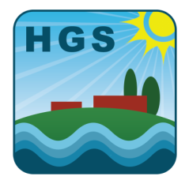

HEBDEN GREEN COMMUNITY SCHOOL

PUPILS

Holidays – July 2024 - July 2025

190 teaching days and 5 inset days: Total 195 days

|  |  |  |
| --- | --- | --- |
|  | Date of Closing for Pupils | **Date of re-opening for Pupils** |
| Summer 2024 | 24th July (Wednesday) | 5th September (Thursday) |
| Autumn half-term 2024 | 25th October (Friday) | 4th November (Monday) |
| Christmas 2024/2025 | 20th December (Friday) | 6th January (Monday) |
| Spring half-term 2025 | 14th February (Friday) | 24th February (Monday) |
| Spring Break 2025 | 4th April (Friday) | 23rd April (Wednesday) |
| May Day bank holiday 2024 | 2nd May (Friday) | 6th May (Tuesday) |
| Summer half-term 2025 | 23rd May (Friday) | 2nd June (Monday) |
| Summer 2025 | 23rd July (Wednesday) | TOTAL 195 days – 5 Inset dates |

### Staff Training Days

1. Monday 2nd September 2024
2. Tuesday 3rd September 2024
3. Wednesday 4th September 2024
4. Monday 10th March 2025
5. FRIDAY 23RD MAY

